**Personal Emergency Alert System**

**Team Members:**

1. **Sandeep Kumar Dara**
2. **Raghavender Jarupati**
3. **Anil Seshu kumar Akula**
4. **Tilak Dhulipalla**

**Abstract:**

This project is to develop a personal emergency alert system for individuals. This application allows the users to send alerts their family/friends for help. This application will help the app users to send the alert message in any havoc to their desired contacts they can set up the contact list to whom the message/alert should be sent, we are planning to implement the location based GPS system to send the location of the user.

**Business Scenario:**

Any individual can use this application especially the one who is in any emergency and cannot contact a person or police department by using a single click button.

**Modules:**

|  |  |  |  |  |
| --- | --- | --- | --- | --- |
| **No.** | **Module** | **Requirement/**  **Functionality** | **Essential or**  **Desirable** | **Description of the Requirement** |
| Rs1 | Login page | Login to their account | Essential | Allows user to login to their account |
| Rs2 | Edit contact | Add contacts including mobile number, email and social media | Essential | Add contact to their emergency contact list |
| Rs3 | Alert home page | Sending alert | Essential | Sending the information of user and their location |
| Rs4 | Alert home page | Categorize non-critical alerts | Essential | Sending the information of user and their location |
| Rs5 | Alert feedback page | Send alert via text message, email and social media | Essential | Sending the information of user and their location |

**Software Requirements:**

* Android sdk
* Android studio/Eclipse
* Java 1.8 and above
* Android Virtual Device(AVD)/Emulator
* SQLite db

**Minimum Hardware Requirements:**

* 512MB Ram and above.
* 4GB of Hard disk
* Dual core Processor

**Flow:**

* User can login/signup using his credentials.
* Then he can see his contact list with an edit button and add contacts if he does not

Have any contacts that have not been setup yet he can click add contacts which will redirect to the contacts page.

* In contacts page he can choose his contacts and add them to the contact list of the user
* Whenever the user want to send an emergency message he can open the app and select the category of alert (critical or non-critical) and send the emergency message by clicking the button and their location to the contacts in his list.
* We are trying to implement this using message and mail.

Milestone 1:

* Uses an outside API :

Mobile contacts

* Requires functionality we will not talk about :
* Intents
* onClick() functions for Buttons
* Requires functionality we will talk about later (maps, media, data base services, etc.)
* Validations
* Import contacts
* Location services
* Swiping functionality
* Message triggering to individual groups
* Triggering password reset link
* Implementing SQLITE database services
* Saving user data

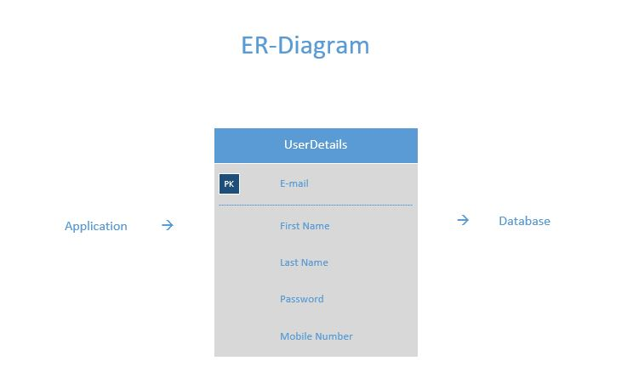

**Steps:**

1. **Login Details**

User name: mike@gmail.com

Password: mike

1. **Click pencil icon beside Manage Your Contacts**

**3. Contacts to be selected**

* Click on list view items Tilak and Sandeep.

1. **Click on send alert or go back to home page and click any emergency button to get feedback about message**
2. **Click logout to logout from the user account.**